A Letter to our Customers, Neighbors, and Friends
At this point, we are all too familiar with terms like “social distancing” and the best practices being recommended by public health officials to contain the spread of the novel coronavirus causing a highly contagious infection known as COVID-19.
Here at the four offices of Edison National Bank/Bank of the Islands, we remain committed to being your community bank by safely helping our customers with all their banking needs throughout this pandemic.
- We have a fully functioning Pandemic Task Force in-house and are following the institutional guidelines issued by the Centers for Disease Control (CDC).
- You can rest assured that our bank employees and overnight cleaning crews are regularly disinfecting all bank surfaces throughout banking hours and during after-hours cleaning services.
- Our employees are required to stay home if they or their family members have symptoms of exposure. We ask our customers to follow these same guidelines and avoid visiting bank offices if they are experiencing symptoms or have been in contact with someone who has shown signs of illness.
- While we plan to remain open at all four bank offices, we encourage our customers to take advantage of online and mobile banking through our convenient OnLine AnyTime internet banking portal and mobile app. Mobile depositing is also available to our customers. You can learn more at https://edisonnationalbank.com/mobile-banking/.
- Please remain aware that our bank is a Presto! network member. That means you can access funds from your accounts with no fee at all Publix supermarkets through the PRESTO! network ATMs. Locations can be found at https://www.publix.com/locations.
As the oldest locally owned and managed community bank in Lee County, we have a longstanding commitment to serving our customers and neighbors. In especially challenging times like these, you can be secure in the knowledge that this commitment will guide us in serving you and your banking needs.
You can continue to follow evolving federal government guidance by checking in at https://www.cdc.gov/coronavirus/2019-nCoV/index.html. If you or a family member are in a high-risk category due to age or underlying health conditions, we strongly encourage you to familiarize yourself with and follow the relevant CDC guidelines.
You can also track the progression of COVID-19 in Florida at http://www.floridahealth.gov/diseases-and-conditions/covid-19/. For any other questions related to COVID-19 in Florida, you can contact our state’s COVID-19 Call Center 24/7 by calling 1-866-779-6121. Your questions can also be emailed to COVID-19@flhealth.gov.
On behalf of our bank’s directors, officers, and banking professionals.
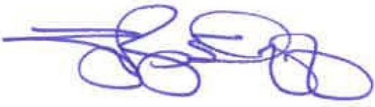
Geoffrey W. Roepstorff
Chief Executive Officer

